References: Basics of Git and using VS Code with Git
Reverting Back to a Previous Commit in Git
Branching and Merging in Git
Connecting Git to GitHub
Open Git bash
pwd : current file path
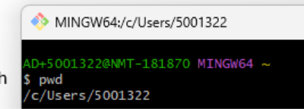
ls : show all files
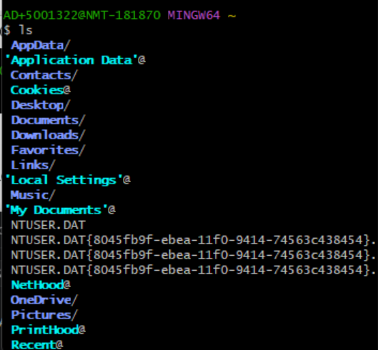
Create new folder in your current file path, for example: Week6 Git
Using cd go to the folder you created. Note: “”
git init: Initialize a repository: Now we have an empty repository that we can start adding and committing files to. So, it takes those snapshots of the history of this file path.
Open visual studio code and from file/open folder, open the Week6 Git folder
Click on source control and you can see it is connected.
In visual studio code, add a new python file to the Week6 Git folder. (file/new file/choose Python file), then add some lines of code to the Python file. Then save the Python file. (file/save)
Write ls in git bash:
Get Some information using git status
Git add . (dot) Means add everything. You can just include one file name.
When commit you should have a message. In the below example the message is “this is my first commit”
Git log: show previous commit, look at the yellow very long line, it is a hash we can use to revert back to snapshot.
Back to visual studio code and you can see new commit.
Add new line of codes to your first_file.py. Then you can see M sign which come from modified.
Add a new python file to the Week 6 git folder. U means untrack.
Click on source control tab. And just do stages changes for the first file. Click on + sign.
Now you can see in the image below we have two sections: staged changes and changes. Look at below image, add go to staging area
Add new commit and click on commit.
Stage the second_file.py as well and add third commit.
Revert to the previous commit
In git bash write git log
Write git checkout and your first hash commit:
Use ls in git bash, you can see just first_file.py has appeared. Also look at the visual studio code.
Also first_file.py is reverted to the first as well.
Using git checkout master: come to our most recent commit in this branch.
Now see the files using ls and visual studio code.
Creating a branch is like below image: you can create a branch and work on it then merge it to the master; someone else can do the same as well.
You can choose any name for your branch the name of branch in the below example is branch_for_work
The hash is for the second commit. Now you can see our current branch has changed.
Branching and Merging
Do: git checkout master
The create another new branch from master branch
Switch back to branch_for_work
Go to visual studio code and change the first_file.py and add new Python file. Run the codes to see the M and U sign.
Now we want to merge it to master branch so other people can see it. So back to the master branch.
When you do git status you notice below things:
So do the merge
Do git log
Do git add . Then get status to check everything.
Now we should commit it.
Look at the visual studio code. Everything is there.
Connecting local Git repository to online GitHub remote repository:
Login to your GitHub, create a new repository using click on new repository, choose a name and select public or private. GitHub suggest you some commands:
We use the below command to connect git to GitHub
Then go to visual studio code and click on source control tab and click on publish branch, then you can see the project is on GitHub.
Refresh GitHub to see the files.

